class Seat < ActiveRecord::Base

validates :baggage, :numericality => { :less_than_or_equal_to => :baggage_allowance }, :presence => true  
belongs_to :flight  
  
def baggage_allowance  
 flight.baggage_allowance  
end   
*************************************

The (red) vlaidation line directs to perform the following:  
  
1. Take a look at the 'baggage' column in the **seats table**  
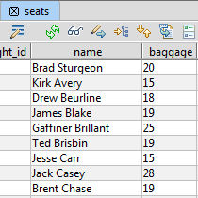

# 2. When new passanger info is added make sure that integer provided in the 'baggage' field is leass than or equal to the value specified in the 'baggage allowance' for particular flight

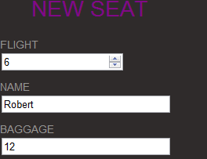 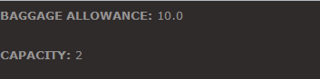

# in the flights table (in the baggage_allowance column)

# 3. in order to be able to compare the values in different tables, relationship between the models has to be established,

# which is done with the following line: belongs_to :flight.

# "Belongs_to" defines a relationship from an object to its parent - in this case between 'seats' table and 'flights' table.

#

belongs_to :flight

def baggage_allowance

flight.baggage_allowance

end